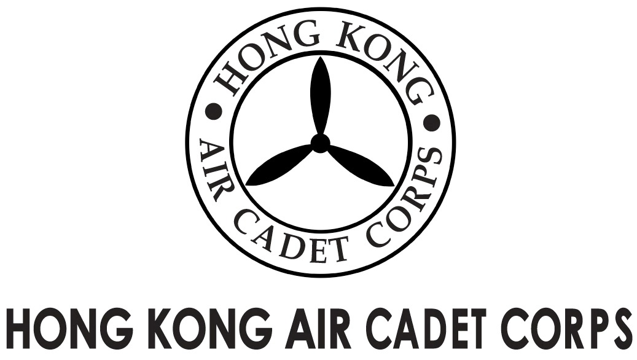
ADMINISTRATION AND SUPPORT GROUP.

From | OC PA Flt  Saki L W LEE  (sakilee0906@gmail.com) | To  Copy to | OC No. 103, No. 308  Major Unit Commanders
Our Ref | GOSA/2017/4 | # of Pages | 1
Date | 11-Dec-2017 | Your Ref

Grantham Uniformed Youth Groups Outstanding Service Award
葛量洪青少年制服團隊傑出服務獎
Nomination Results

Please take note that the Selection Panel has nominated the following cadets to the Secretariat of the Grantham Scholarships Fund for the consideration of the captioned award after reviewing the applications endorsed by OC No.1, 3 Wg.

- Cadet Sergeant HO Ho-yin; and
- Cadet Sergeant FUNG Chi-wai

May I take this opportunity to congratulate Sgt HO and Sgt FUNG for their successful interviews on behalf of the Selection Panel.

Sgt HO and Sgt FUNG have impressed the Panel with their excellent service records, passion and calibre. I would like to take this opportunity to wish them every success with their roles in the Corps and in society.

Yours sincerely,

Saki L W LEE
Flying Officer
OC PA Flt

